

**HWS Microsoft Login**

**with DoubleClue**

**Multi-Factor Authentication**

Inhalt

1. Introduction 3

2. Activating the DoubleClue App 3

2.1 Installation of the Desktop App 4

3. Authentication Methods 5

3.1 Push Approval 5

3.2 QR Code Approval 6

3.3 DoubleClue Passcode 6

3.4 Voice Message 6

4. Logging into Office Online with DoubleClue MFA 6

4.1 Login with QR Code 8

4.2 Offline Login with DoubleClue Passcode 9

4.3 Login with Voice Message 11

5. Problem when Using Apple Mail on same Device as DoubleClue App 11

# Introduction

HWS secures the employee access to all Windows Services (e.g. Teams, Outlook, Sharepoint, Office Online etc.) with DoubleClue multi-factor authentication (MFA). DoubleClue enhances the safety of the normal login process with username and password by asking the user for a second method to confirm their identity. In this guide, we will introduce the different MFA methods supported by DoubleClue and explain how they work.

The citrix access for adidas is not secured with DoubleClue. The following information does not apply to it.

# Activating the DoubleClue App

DoubleClue comes with its own app for Android and iOS devices. The DoubleClue App provides the most comfortable and secure methods for the authentication with DoubleClue. We will therefore walk you through the steps to download and activate the DoubleClue app.

1. Download the DoubleClue App from [Google Playstore](https://play.google.com/store/apps/details?id=com.doubleclue.android&hl=gsw) or [Appstore](https://apps.apple.com/de/app/doubleclue/id1296803375).
2. On your work desktop computer, log into DoubleClue UserPortal at <https://doubleclue.hws-gruppe.de/dcem/userportal/> with your HWS username (eg. [john.smith@hws-gruppe.de](mailto:john.smith@hws-gruppe.de) for Germany, [john.smith@hws-technologies.com](mailto:john.smith@hws-technologies.com) for Malta) and password. Should you encounter any problems logging in, please ensure that you are connected with the internal HWS network of the office.Other connections, like the HWS Guest Wifi, will not suffice. If you receive an error message telling you that you have no devices, you are not connected through the correct network.

C:\Users\maike.behnsen\Desktop\Grafiken\caution-sign.pngSome ad blockers prevent the correct display of DoubleClue in your browser. If you use an ad blocker ensure that you add DoubleClue to your whitelist.

1. Once you have logged into UserPortal, select “Add New Device”
2. Select “Smart Device”.
3. Choose any of the available “Send by” options. You will always see an alphanumeric activation code as well as a QR code in your browser.

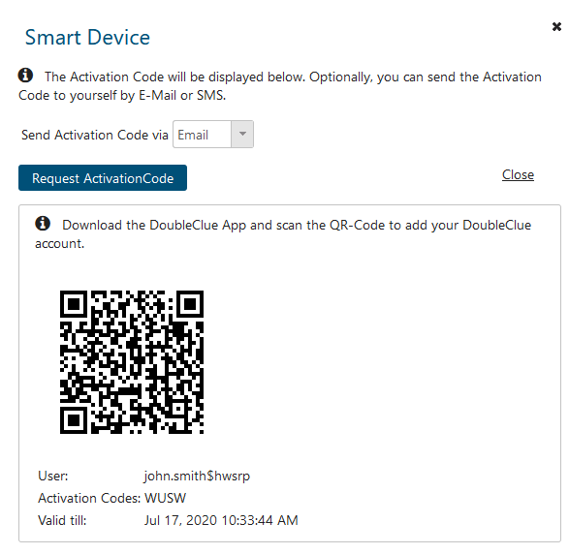

If you do not regularly work in the HWS office and can’t access the UserPortal to send yourself an activation code or have problems logging in, contact [support@doubleclue.com](mailto:support@doubleclue.com)

1. Open the DoubleClue App and activate it by scanning the QR Code or manually entering the number code you received from the UserPortal.
2. Enter your HWS password to activate the app. If you get an error message, check if the entered username is correct. The username to activate the app is not the same as your normal HWS name, but your username plus the suffix $hws (eg. John.smith$hws). The username for the activation will also be displayed when requesting an activation code.
3. Log into the app with your username and password or biometric authentication. Your app is now active and can be used for HWS authentication.

## Installation of the Desktop App

Alternatively, can use the DoubleClue Desktop app on your laptop instead of the mobile app.

1. Download the installer for the DoubleClue Desktop App at <https://doubleclue.com/files/DoubleClue-Desktop.zip>
2. Execute the DoubleClue-Desktop.exe
3. At the beginning of the installation, you will receive a warning from Windows. Click on “More Details” and then on “Install Anyway”. We advise to install the desktop app with default settings.
4. Activate the desktop app by entering your HWS username and password together with the activation code you requested in UserP. The desktop app doesn’t support the activation with QR code.
5. Log into the Desktop App with your HWS username plus $hws (eg. john.smith$hws) and password to complete the activation process.

# Authentication Methods

The HWS DoubleClue supports different MFA methods for logging into Microsoft applications from external networks.

The enabled authentication methods are:

* Push Approval
* QR Code Approval
* DoubleClue Passcode
* Voice Message

Please Note:   
If you want to access a Microsoft application while connected via the HWS network, due to being in the office or connected via VPN, a simple authentication with username and password will suffice.

## Push Approval

Push Approval is the default authentication method. You need to install and activate the DoubleClue App on your smart device or Windows desktop. After entering your username and password, you will receive a notification on your Smart Device. Click onto the notification, and you will be automatically redirected to the DoubleClue app. Confirm the login attempt in the app and you will gain access to the service.

Please note that you won’t receive a notification on your desktop app. Log into your desktop app before entering username and password to access the service.

## QR Code Approval

QR Code Approval allows you to log in without username and password by scanning a QR Code with your DoubleClue app. This login method is only available in the DoubleClue mobile app, not in the desktop app.

## DoubleClue Passcode

DoubleClue Passcode can also be used when the app is offline and you are not logged in. In the DoubleClue App, you can request an alphanumeric login code displayed by the app which is viable for 60 seconds. After entering your username and password, you also enter the code to identify yourself.

## Voice Message

After entering your username and password, you receive a phone call on the number you forwarded to HWS. The caller will tell you a code to enter into the field displayed by DoubleClue.

# Logging into Office Online with DoubleClue MFA

We use Office Online as an example on how to log into a Windows Service with DoubleClue MFA.

1. Log into Office Online with your HWS e-mail

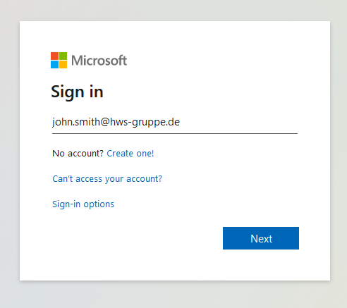

1. You will be automatically redirected to the HWS DoubleClue login page. Enter your HWS username and password. You can also check “*Stay Logged In*” and DoubleClue will remember your browser, so that you can skip the authentication process for 90 days when accessing a Windows service with this browser.

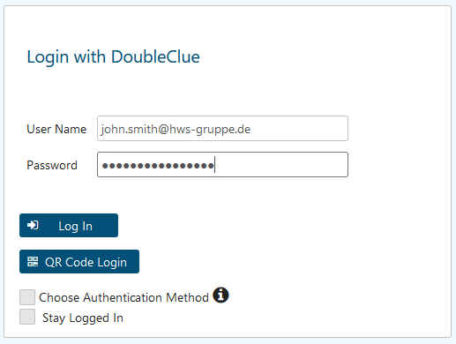

1. If you log in from the HWS network, you only need to identify yourself with username and Password. If you want to log in from another location, DoubleClue will demand multi-factor authentication. By default, Push Approval is used as MFA method.
2. After entering your username and password, you will receive a Push Notification on your smart device or in the desktop app. Click on the notification and DoubleClue will open automatically, so that you can confirm the login.

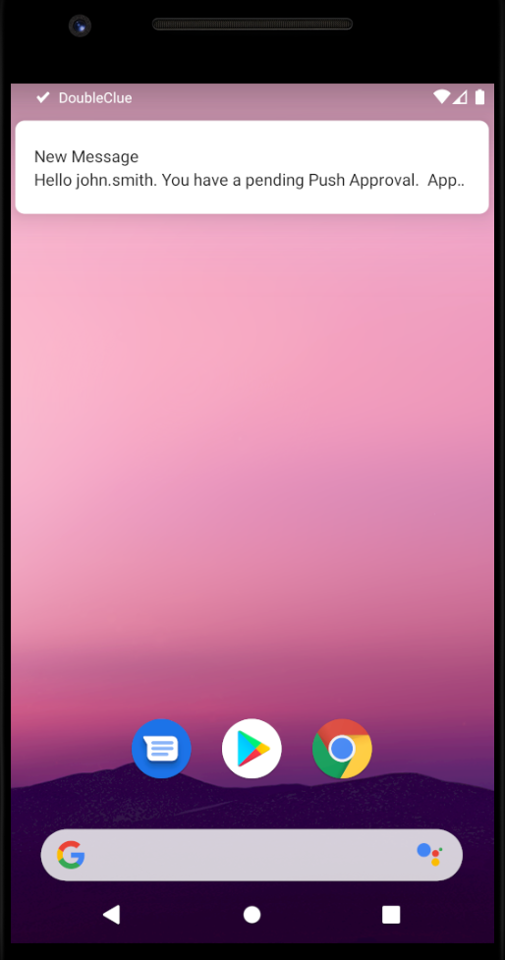 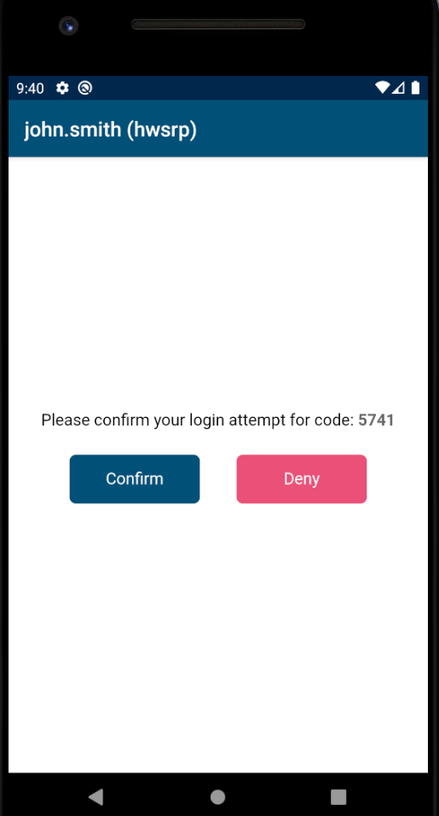

## Login with QR Code



QR Code Login is a quick and easy way to authenticate yourself with your DoubleClue mobile app.

1. After you have been redirected to the DoubleClue login, instead of entering your credentials, click on “QR Code Login”. A QR Code will be displayed in the login mask.
2. Log into your DoubleClue app
3. Click on the “QR Code Approval” button.
4. Scan the displayed QR Code and you gain access to the service.

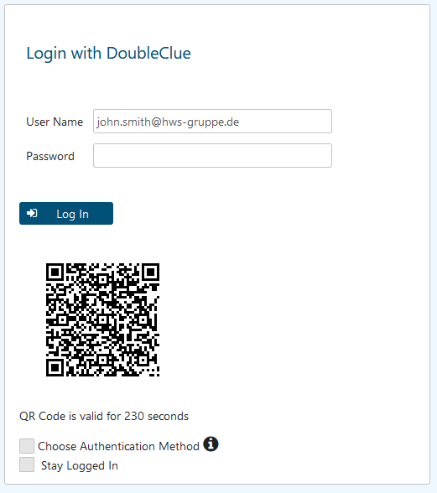

## Offline Login with DoubleClue Passcode

When your app is currently not online, it cannot receive Push Approvals. In this case, you can use DoubleClue Passcode to log in.

1. When entering your credentials, check “Choose Authentication Method”.

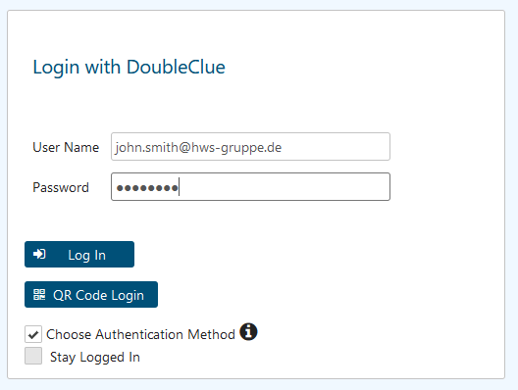

1. After your credentials have been evaluated, you will see a list of available authentication methods.

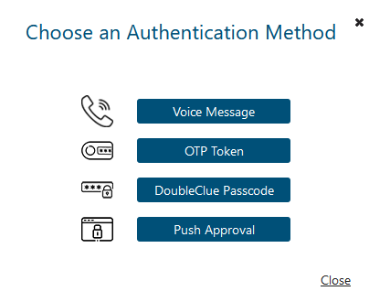

1. Choose DoubleClue Passcode.

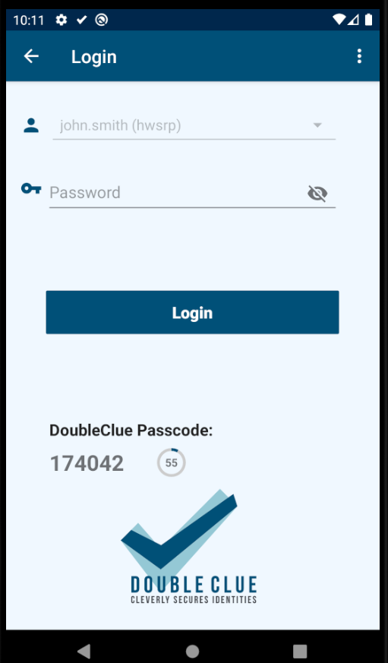

1. Enter the displayed numeric code into the field in the browser and proceed with the log in.

## Login with Voice Message

1. When entering your credentials, check “Choose Authentication Method”.
2. After your credentials have been evaluated, you will see a list of available authentication methods. Select Voice Message.
3. Accept the phone call to receive the code.
4. Enter the number code in the field displayed in your browser.

Should you encounter any problems, please contact [support@doubleclue.com](mailto:support@doubleclue.com).

# Problem when Using Apple Mail on same Device as DoubleClue App

There is currently a problem when you use Apple Mail on the same device as the DoubleClue App. As the HWS mail accounts are protected with DoubleClue MFA, you will need to verify your identity with MFA when logging into your HWS mail account with Apple Mail.

However, Apple Mail does not allow you to open any other apps during the log in or it will cancel the process. You therefore cannot open the DoubleClue app on your iPhone to confirm your Push Approval.

You can use the following workaround:

1. To avoid this problem, we advise to install Outlook on your iPhone. You can download it for free from the App Store.
2. Alternatively, you can download the DoubleClue Dekstop App, as described in chapter 2.1 Installation of the Desktop App.
   1. Login in Desktop App
   2. Login to Apple Mail
   3. Confirm the Push Approval on your Desktop App.
   4. You should now be logged in to your Apple Mail HWS account.

You will only need to do this once every 90 days or when you change your HWS password.